Resolution Scaling and Backbone Capacity in Few Shot Image Classification
Abstract
Input resolution and backbone capacity jointly shape the accuracy and resource requirements of few-shot image classifiers. This study examines their trade-off within an ImageNet-initialized Prototypical Network pipeline. MobileNetV3-Small, MobileNetV3-Large, and ResNet-18 are evaluated at 84×84 and 224×224 on MiniImageNet and CUB-200-2011, using three training seeds per configuration and 5-way 1-shot and 5-shot tasks.
Increasing resolution improves mean MiniImageNet accuracy by 4.61–13.88 percentage points in 1-shot and 4.18–9.06 points in 5-shot. Corresponding gains on CUB are 9.44–16.39 and 6.27–10.65 points. Matched-episode analyses cover all 12 dataset–backbone–shot comparisons, with 6,000 paired episodes per comparison and positive differences throughout. MobileNetV3-Small at 224×224 exceeds MobileNetV3-Large at 84×84 on both datasets while using 68.8% fewer parameters and approximately 1.51 times its reported compute. A separate single-seed sweep attains its highest observed accuracy at 224×224 and lower accuracy at 256×256.
These results support considering resolution alongside architecture under explicit resource constraints. Interpretation remains conditional on external pretraining, resolution-dependent batch sizing, and the reported data splits. The matched-episode intervals quantify task-level uncertainty for the fitted models, not the full uncertainty of retraining. The study provides empirical guidance on accuracy–resource trade-offs without establishing a universal optimal resolution or a controlled benchmark ranking.
Keywords
Few-shot classification; input resolution; backbone capacity; Prototypical Networks; MobileNetV3; accuracy–compute trade-off.
1. Introduction
Few-shot image classification aims to recognize novel categories from only a handful of labeled examples. Because supervision per novel class is scarce, the quality of the learned visual representation is disproportionately important. Metric-based methods such as Prototypical Networks (ProtoNet) address this by learning an embedding space in which same-class examples cluster tightly and a class prototype — the mean support embedding — serves as an effective classifier (Snell et al., 2017).
Few-shot learning research has placed substantial emphasis on meta-learning algorithms, backbone architecture, pretraining, and feature adaptation. Input size is often fixed within an experimental protocol; 84×84 inputs are common in early MiniImageNet studies (Vinyals et al., 2016; Snell et al., 2017). Resolution nevertheless influences the spatial information available to a feature extractor and its computational cost. This motivates examining resolution alongside backbone choice, particularly for fine-grained recognition, where distinguishing cues may be spatially localized.
This study asks whether a compact backbone supplied with higher-resolution inputs can outperform a larger backbone supplied with lower-resolution inputs. We compare a common ProtoNet formulation across backbone and resolution settings, using a shared two-stage training recipe. Batch size also changes with resolution, so the comparisons characterize the implemented training configurations rather than a completely isolated causal effect of pixel resolution. All backbones use ImageNet-pretrained initialization; this external supervision defines the scope of the results.
The contributions are a three-backbone, two-dataset analysis of resolution sensitivity in 1-shot and 5-shot classification; complete pooled matched-episode coverage of these 12 comparisons; and a resource analysis that distinguishes parameter count, reported backbone compute, and measured ResNet-18 runtime. An exploratory five-resolution sweep complements the main two-point comparison. Per-seed accuracies are provided for both datasets, and the uncertainty convention and rounding rules are stated explicitly.
2. Related Work
2.1 Few-Shot and Metric-Based Learning
Few-shot learning is commonly formulated as episodic learning over tasks composed of support and query sets. Early approaches include Matching Networks (Vinyals et al., 2016), Model-Agnostic Meta-Learning (Finn et al., 2017), and optimization-based meta-learning (Ravi and Larochelle, 2017). Prototypical Networks (Snell et al., 2017) represent each class by the mean embedding of its support examples and classify queries according to distance to these prototypes, providing a simple and effective metric-learning framework for controlled comparisons such as the one conducted here.
2.2 Backbone Capacity and Efficient Recognition
Backbone design influences the quality and transferability of learned visual representations. Residual architectures (He et al., 2016) and MobileNetV3 architectures (Howard et al., 2019) provide distinct parameter and computational profiles. Chen et al. (2019), Tian et al. (2020), and Chen et al. (2021) emphasize the importance of the learned embedding and training protocol when interpreting few-shot performance. Motivated by this perspective, the present study compares resolution and backbone choice within one implemented pipeline. Architecture changes involve more than parameter count, so observed differences should not be interpreted as the effect of capacity alone.
2.3 Input Resolution as a Scaling Dimension
Resolution is an established scaling dimension in image recognition. EfficientNet jointly scales network depth, width, and input resolution (Tan and Le, 2019), while subsequent work examines computational and runtime implications of compound scaling (Lin et al., 2023). Touvron et al. (2019) study discrepancies between training and test resolution, and Bakhtiarnia et al. (2024) review efficient high-resolution deep learning. Within few-shot recognition, Liu et al. (2024) investigate low-resolution learning through knowledge distillation. These studies motivate an explicit examination of resolution–resource trade-offs; they do not establish that increasing resolution must improve every backbone or training setting.
2.4 Representation Adaptation in Few Shot Recognition
Embedding adaptation and pretrained representations are central to several few-shot methods, including FEAT (Ye et al., 2020), DeepEMD (Zhang et al., 2020), and attention-focused adaptation (Wang and Jie, 2023). Broader developments are reviewed by Zeng and Xiao (2024). The present experiments evaluate convolutional backbones only. Their results therefore do not establish the resolution sensitivity of transformer models or explain differences between convolutional and transformer-based benchmarks.
2.5 Research Gap
The specific objective is to quantify how resolution choices interact with backbone choice, shot count, and resource consumption in the reported ProtoNet pipeline. The study contributes an internally comparable empirical analysis rather than an exhaustive claim that no earlier work has examined these factors jointly. Its findings are interpreted within the available pretraining, class-split, batch-size, and evaluation conditions.
3. Experimental Methodology
3.1 Research Design
The main design crosses two input resolutions (84×84 and 224×224), three backbones (MobileNetV3-Small, MobileNetV3-Large, and ResNet-18), and two datasets (MiniImageNet and CUB-200-2011). Each configuration has three training seeds and is evaluated in 5-way 1-shot and 5-shot settings. The pipeline comprises ImageNet-pretrained initialization, supervised training on base classes, episodic ProtoNet training, and evaluation on classes held out from the study-specific training stages. Resolution-dependent batch sizing is an additional varying factor. External pretraining limits claims that MiniImageNet test classes are unseen throughout the full training history.
3.2 Datasets and Class Splits
MiniImageNet comprises 100 classes drawn from ImageNet (Vinyals et al., 2016; Russakovsky et al., 2015). The reported experiments use 64/16/20 training, validation, and test classes; counts alone do not establish that class identities match a particular published split. CUB-200-2011 comprises 200 bird categories (Wah et al., 2011) and uses a fixed 100/50/50 class split generated with random.Random(42). Reproducing this split also requires the ordered class list and splitting procedure. The CUB partition has not been verified against canonical few-shot splits. Results are therefore interpreted primarily as within-study comparisons. ImageNet-pretrained initialization introduces an additional qualification: if standard full ImageNet-1K weights were used, MiniImageNet test categories were included in pretraining. The exact weight identifiers and any image-level overlap audit are not documented in the available experimental record. Class disjointness here refers to the study-specific training stages, not to external pretraining.
3.3 Prototypical Network Formulation
Each episode contains five classes, K support images per class, and Q query images per class. The backbone produces an embedding fθ(x). For class k, its prototype is cₖ = (1/|Sₖ|) ∑ᵢ∈Sₖ fθ(xᵢ), where Sₖ indexes the class support images. A query image x receives class logit −‖fθ(x) − cₖ‖², and cross-entropy is applied to the softmax over these logits (Snell et al., 2017). The reported pipeline uses no projection head, learnable temperature, or embedding L2 normalization. This common classifier keeps the metric-learning formulation consistent across configurations; other training differences are discussed in Section 3.4.
3.4 Training Protocol
The reported training recipe has two stages. Stage 1 fine-tunes the ImageNet-pretrained backbone as a supervised classifier for 10 epochs using SGD with learning rate 0.01, momentum 0.9, Nesterov acceleration, weight decay 1×10⁻⁴, and cosine annealing. Stage 2 removes the classification head and uses Adam with learning rate 1×10⁻⁵. The available record describes 2,000 meta-training episodes, with 5 classes, either 1 or 5 support examples, and 15 query examples per class. It does not establish whether the episode counter denotes individual tasks or batched optimizer steps; this limits comparison of optimization budgets across resolutions.
The reported build_transforms function applies a shared resize-and-crop policy across input resolutions. This is intended to keep the augmentation strategy consistent, but the exact resize ratios, interpolation mode, crop parameters, and evaluation transforms are not fully specified in the available record. The source-image resolution also needs to be documented: enlarging already downsampled images does not recover lost visual detail. Accordingly, the results are described as sensitivity to input resolution without asserting a verified mechanism of additional information recovery.
The configuration records BATCH_SIZE_BY_RESOLUTION = {84: 48, 112: 32, 168: 24, 224: 16}. The available description does not resolve whether these values refer to supervised image batches or episodic task batches. The 256×256 batch setting is not specified. The intended rationale is memory management, but comparable memory utilization across training configurations has not been demonstrated. Because batch size co-varies with resolution, its influence on optimization cannot be separated from resolution using the reported comparisons, and the direction of this influence is unknown.
3.5 Reproducibility and Statistical Analysis
Tables 1 and 4 reproduce the final experiment summaries as mean ± SD across three seeds. The reported SDs are consistent, to rounding precision, with the population-form descriptive standard deviation: SD = √[(1/3)∑ᵢ₌₁³(aᵢ−ā)²]. They are not sample SDs with denominator n−1, standard errors, or confidence intervals. The per-seed accuracies in Appendices A and B are rounded to two decimals; averaging them can differ from a logged aggregate by 0.01 pp, so the final logged aggregates are retained. Descriptive gains in Table 2 are differences between displayed aggregate means. Matched-episode summaries use a separate evaluation of identical tasks at both resolutions: 2,000 paired episodes per seed, pooled over three seeds (6,000 pairs per dataset–backbone–shot comparison). Their means and paired differences are retained as reported. The displayed p=0.000000 values are reported as p < 10⁻⁶, not as zero. Episode-level intervals and tests are conditional on fitted model pairs and do not replace an analysis of training-seed variability. Seed-specific paired outputs and raw episode arrays are not available for independent reanalysis.
3.6 Computational Profiling
Table 5 retains the reported parameter counts and backbone operation estimates for all three backbones. The source record labels the operation estimates GFLOPs while describing multiply–accumulate operations; whether one MAC counts as one or two FLOPs is not specified. We therefore use these numbers as reported compute estimates, with relative ratios interpreted under a common counting convention. Table 6 provides ResNet-18 episode latency, throughput, and peak memory. Hardware model, software versions, precision, warm-up, synchronization, and measurement repetitions are not fully documented, so these measurements should be treated as within-run observations rather than portable deployment benchmarks.
4. Experimental Results and Discussion
Across the reported configurations, 224×224 inputs yield higher mean accuracy than 84×84 inputs. The following sections distinguish replicated run-level summaries, conditional matched-episode statistics, and an exploratory resolution sweep.
4.1 Main MiniImageNet Results
Table 1. Final MiniImageNet 5-way accuracy (%), reported mean ± descriptive SD across three seeds. SD uses the population-form convention (denominator n=3); values are retained from the final experiment summaries.
Backbone | Resolution | 1-shot (%) | 5-shot (%)
MobileNetV3-Small | 84×84 | 60.22 ± 0.94 | 81.59 ± 0.21
MobileNetV3-Small | 224×224 | 74.10 ± 0.09 | 90.65 ± 0.38
MobileNetV3-Large | 84×84 | 69.64 ± 0.15 | 88.62 ± 0.37
MobileNetV3-Large | 224×224 | 80.09 ± 0.96 | 93.08 ± 0.19
ResNet-18 | 84×84 | 64.29 ± 0.42 | 81.89 ± 0.54
ResNet-18 | 224×224 | 68.90 ± 0.79 | 86.07 ± 0.39
MobileNetV3-Small improves from 60.22% to 74.10% in 1-shot and from 81.59% to 90.65% in 5-shot. Its 1-shot gain (+13.88 pp) exceeds those of MobileNetV3-Large (+10.45 pp) and ResNet-18 (+4.61 pp). MobileNetV3-Large has the highest absolute accuracy at both resolutions, reaching 80.09% and 93.08% at 224×224. ResNet-18 has more parameters than either MobileNet but lower accuracy here, so parameter count alone does not explain the ranking.
4.2 Resolution Scaling Gains
Table 2. Accuracy gains from 84×84 to 224×224, in percentage points (pp). Each value is the difference between the final displayed aggregate means in Tables 1 and 4.
Backbone | MiniImageNet  1-shot gain | MiniImageNet  5-shot gain | CUB  1-shot gain | CUB  5-shot gain
MobileNetV3-Small | +13.88 | +9.06 | +16.39 | +10.65
MobileNetV3-Large | +10.45 | +4.46 | +11.54 | +6.86
ResNet-18 | +4.61 | +4.18 | +9.44 | +6.27
The 1-shot gain exceeds the 5-shot gain for every backbone on both datasets (Figure 1). Gains are larger on CUB than on MiniImageNet in all six corresponding backbone–shot comparisons. Averaging several support embeddings may reduce sensitivity to individual examples, but no prototype-variance experiment was conducted. Dataset and architecture differences may also interact with pretraining and optimization; the observed pattern does not isolate a single mechanism.
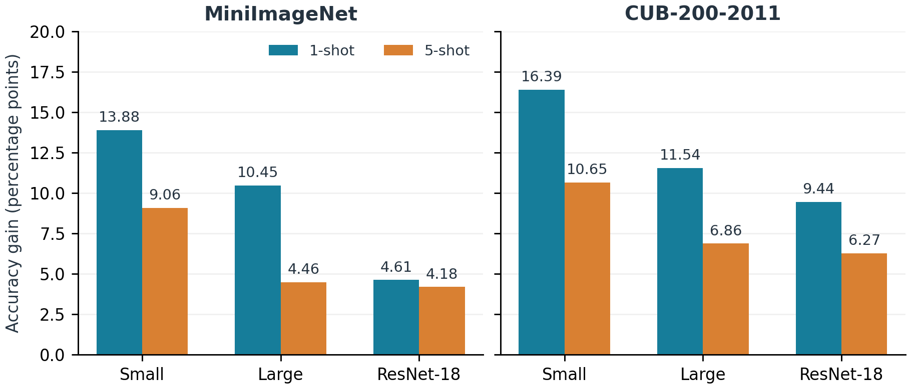
Figure 1. Accuracy gains from 84×84 to 224×224 on both datasets, computed from the final three-seed aggregate means. Bars show descriptive differences, not confidence intervals.
4.3 Matched-Episode Statistical Evidence
Tables 3a–3c report the final pooled matched-episode analyses for all three backbones on both datasets and in both shot settings. Every row contains 6,000 paired episodes (2,000 per seed). Identical sampled support/query tasks are used across the two resolutions within each comparison. All reported paired t-tests and Wilcoxon tests have p < 10⁻⁶. These tests support positive task-level differences conditional on the trained models; pooling episodes does not create additional independent training replications.
Table 3a. Final MobileNetV3-Small pooled matched-episode results. Accuracy values are percentages and Δ is in pp; ± denotes the reported 95% CI half-width for the paired mean difference. Each row has n=6,000 pairs. Both tests report p < 10⁻⁶ in every row.
Dataset | Shot | 84×84 (%) | 224×224 (%) | Δ ± 95% CI  (pp) | Paired t | Wilcoxon W
MiniImageNet | 1-shot | 60.40 | 74.63 | +14.23 ± 0.24 | 116.2059 | 245457.0
MiniImageNet | 5-shot | 81.60 | 90.42 | +8.82 ± 0.14 | 120.5234 | 143671.0
CUB | 1-shot | 64.98 | 81.22 | +16.24 ± 0.24 | 133.5245 | 87483.5
CUB | 5-shot | 82.46 | 93.06 | +10.60 ± 0.14 | 145.2866 | 21139.5
MobileNetV3-Small has paired gains of +14.23 pp and +8.82 pp on MiniImageNet, and +16.24 pp and +10.60 pp on CUB, for 1-shot and 5-shot respectively. Its positive effect is therefore present in both datasets and shot settings. The paired estimates differ slightly from Table 2 because the matched and main summaries come from separate evaluation samples.
MobileNetV3-Large also has complete pooled paired results in both shot settings and on both datasets (Table 3b).
Table 3b. Final MobileNetV3-Large pooled matched-episode results. Accuracy values are percentages and Δ is in pp; ± denotes the reported 95% CI half-width. Each row has n=6,000 pairs. Both tests report p < 10⁻⁶ in every row.
Dataset | Shot | 84×84 (%) | 224×224 (%) | Δ ± 95% CI  (pp) | Paired t | Wilcoxon W
MiniImageNet | 1-shot | 69.81 | 79.92 | +10.11 ± 0.27 | 74.6283 | 1332222.0
MiniImageNet | 5-shot | 88.55 | 92.94 | +4.38 ± 0.13 | 67.1721 | 1462826.5
CUB | 1-shot | 72.63 | 84.48 | +11.85 ± 0.23 | 100.7297 | 419588.5
CUB | 5-shot | 88.04 | 94.66 | +6.62 ± 0.12 | 109.8183 | 159522.0
MobileNetV3-Large has paired gains of +10.11 pp and +4.38 pp on MiniImageNet, and +11.85 pp and +6.62 pp on CUB. The 5-shot pooled t and Wilcoxon statistics are supplied in the final outputs and are reported directly; no reconstruction from older seed-level summaries is used.
The final ResNet-18 results cover both datasets and both shot settings (Table 3c).
Table 3c. Final ResNet-18 pooled matched-episode results. Accuracy values are percentages and Δ is in pp; ± denotes the reported 95% CI half-width. Each row has n=6,000 pairs. Both tests report p < 10⁻⁶ in every row.
Dataset | Shot | 84×84 (%) | 224×224 (%) | Δ ± 95% CI  (pp) | Paired t | Wilcoxon W
MiniImageNet | 1-shot | 63.77 | 68.86 | +5.10 ± 0.25 | 40.5917 | 3610481.5
MiniImageNet | 5-shot | 81.99 | 86.01 | +4.01 ± 0.14 | 57.9403 | 1957578.5
CUB | 1-shot | 71.20 | 80.94 | +9.74 ± 0.24 | 80.0900 | 1020976.0
CUB | 5-shot | 86.18 | 92.41 | +6.23 ± 0.12 | 97.8598 | 381829.0
ResNet-18 has paired gains of +5.10 pp and +4.01 pp on MiniImageNet, and +9.74 pp and +6.23 pp on CUB. The larger paired gains on CUB agree with the descriptive pattern in Table 2. Small discrepancies between a reported Δ and subtraction of the displayed accuracy columns reflect separate rounding of the summary quantities; paired Δ values are not replaced by differences of rounded means. No seed-specific paired significance claims are made from the pooled summaries alone.
4.4 Capacity–Resolution Trade-off
On MiniImageNet, MobileNetV3-Small at 224×224 achieves 74.10% in 1-shot and 90.65% in 5-shot, versus 69.64% and 88.62% for MobileNetV3-Large at 84×84. The descriptive margins are +4.46 and +2.03 pp. Small uses 0.927M rather than 2.972M parameters (68.8% fewer), but its reported compute is 0.0609 rather than 0.0404, approximately 1.51× higher. This is a parameter–accuracy advantage with an operation-count penalty; MobileNet latency was not measured.
On CUB, the same comparison yields 81.33% versus 73.22% in 1-shot and 92.64% versus 87.72% in 5-shot, giving +8.11 and +4.92 pp. Both architecture and resolution change between these operating points. The within-backbone paired tests do not establish the statistical significance of these cross-backbone margins; no direct paired test between Small at 224×224 and Large at 84×84 is reported.
4.5 CUB-200-2011 Results
Table 4. Final CUB-200-2011 5-way accuracy (%) for all three backbones, reported mean ± descriptive SD across three seeds. SD follows the population-form convention (denominator n=3).
Backbone | Resolution | 1-shot (%) | 5-shot (%)
MobileNetV3-Small | 84×84 | 64.94 ± 1.12 | 81.99 ± 0.74
MobileNetV3-Small | 224×224 | 81.33 ± 0.17 | 92.64 ± 0.19
MobileNetV3-Large | 84×84 | 73.22 ± 0.61 | 87.72 ± 0.20
MobileNetV3-Large | 224×224 | 84.76 ± 0.41 | 94.58 ± 0.10
ResNet-18 | 84×84 | 71.10 ± 0.38 | 85.88 ± 0.26
ResNet-18 | 224×224 | 80.54 ± 0.74 | 92.15 ± 0.12
On CUB, MobileNetV3-Small improves by +16.39 pp in 1-shot and +10.65 pp in 5-shot. MobileNetV3-Large gains +11.54 and +6.86 pp, while ResNet-18 gains +9.44 and +6.27 pp. MobileNetV3-Large reaches the highest absolute accuracy at 224×224 (84.76% and 94.58%). The corresponding ResNet-18 results are 80.54% and 92.15%, and Small reaches 81.33% and 92.64%. The pooled matched analyses support positive differences for every backbone and shot setting. These are within-study findings; the custom CUB split and external pretraining still limit direct comparisons with published scores.
4.6 Computational Efficiency: Theoretical Compute
Table 5. Backbone parameters and reported operation estimates. *Compute is reported in GFLOPs; its MAC-to-FLOP convention is unspecified. Ratios assume a consistent convention across configurations.
Backbone | Parameters (M) | 84×84  Compute* | 224×224  Compute* | Increase
MobileNetV3-Small | 0.927 | 0.0108 | 0.0609 | 5.64×
MobileNetV3-Large | 2.972 | 0.0404 | 0.2323 | 5.75×
ResNet-18 | 11.177 | 0.2976 | 1.8235 | 6.13×
The pixel count increases by 7.11× from 84×84 to 224×224, while the reported backbone compute increases by approximately 5.64×, 5.75×, and 6.13× for Small, Large, and ResNet-18. Parameter count is unchanged within each backbone. Figure 2 combines the final accuracies with the previously reported compute estimates, which were not reprofiled in the final result files. It distinguishes low parameter count from low operation count; neither establishes a measured latency advantage.
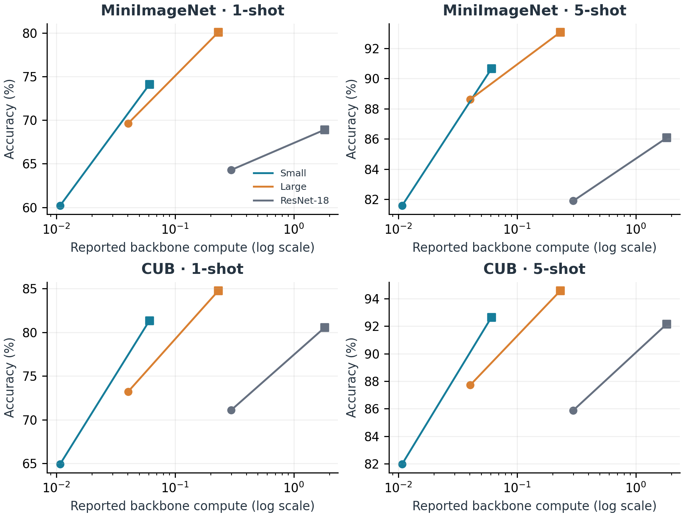
Figure 2. Final accuracy versus reported backbone compute on MiniImageNet and CUB. Circles denote 84×84 and squares 224×224; lines connect the same backbone. Accuracy uses the final three-seed means; compute is retained from Table 5 under its source counting convention.
4.7 Computational Efficiency: Measured Practical Cost
Table 6. Previously reported ResNet-18 practical measurements on MiniImageNet, retained separately from the final accuracy outputs. Latency and throughput are per episode. With 15 queries per class, 1-shot and 5-shot tasks contain 80 and 100 support-plus-query images. MobileNet timings are unavailable.
Resolution | Shot | Latency (ms/episode) | Throughput (eps/s) | Peak Memory (MB) | Params (M)
84×84 | 1-shot | 20.46 | 48.88 | 567.1 | 11.177
84×84 | 5-shot | 24.77 | 40.37 | 599.9 | 11.177
224×224 | 1-shot | 77.95 | 12.83 | 1081.6 | 11.177
224×224 | 5-shot | 88.78 | 11.26 | 1276.0 | 11.177
Moving to 224×224 increases ResNet-18 latency by 3.81× in 1-shot and 3.58× in 5-shot, and peak memory by 1.91× and 2.13×, respectively. Throughput falls correspondingly. These ratios describe the reported measurement setup and cannot be extrapolated to the MobileNet backbones. Direct energy consumption was not measured, and FLOPs or latency alone do not quantify it.
4.8 Contextual Comparison with Published Methods
Table 7. Selected published MiniImageNet 5-way results and the final results of this study. Prior methods are contextual references, not rerun baselines. External pretraining, architecture, resolution, splits, and evaluation protocols are not matched, so the table does not support a state-of-the-art ranking.
Method | Backbone | Input Res. | 1-shot (%) | 5-shot (%)
ProtoNet (Snell et al., 2017) | Conv-4 | 84×84 | 49.42 | 68.20
ProtoNet (instance-embedding reimpl., Ye et al., 2020) | ResNet-12 | 84×84 | 62.39 | 80.53
FEAT (Ye et al., 2020) | ResNet-12 | 84×84 | 66.78 | 82.05
DeepEMD (Zhang et al., 2020) | ResNet-12 | 84×84 | 65.91 | 82.41
This study — ResNet-18 | ResNet-18 | 224×224 | 68.90 | 86.07
This study — MobileNetV3-Large | MobileNetV3-Large | 224×224 | 80.09 | 93.08
The published results provide historical context for the scale of the reported accuracies. Their differences cannot be attributed to resolution because the methods, training data, and model families also differ. In particular, this study uses ImageNet-pretrained initialization; if the weights cover full ImageNet-1K, the MiniImageNet test categories are already represented during pretraining. A conventional claim of generalization to wholly unseen classes or superiority over the listed methods would therefore be unsupported by this comparison.
4.9 Resolution Sweep: Beyond the Binary Comparison
A separate exploratory MobileNetV3-Small sweep evaluates 84, 112, 168, 224, and 256 pixel inputs on MiniImageNet. These earlier results are retained from the resolution-sweep experiment; the final three-seed files do not provide a replacement sweep. Each resolution uses one seed and 500 test episodes. This experiment is not pooled with the final main results, and its values at 84 and 224 need not match their three-seed aggregates. Figure 3 summarizes its observed curve rather than establishing an optimum across seeds or backbones.
Table 8. Exploratory MobileNetV3-Small sweep on MiniImageNet. The ± terms are reproduced from the source summary; their statistical definition is not documented and they must not be interpreted as confirmed 95% CIs or run-level SDs. Relative compute is normalized to 224×224. Gain/compute is defined in the text. *Compute uses the same source counting convention as Table 5.
Resolution | 1-shot (%) | 5-shot (%) | Compute* | Relative  compute | 1-shot gain /  rel. compute
84×84 | 61.06 ± 0.92 | 81.47 ± 0.71 | 0.0108 | 0.177× | —
112×112 | 64.93 ± 0.92 | 85.55 ± 0.60 | 0.0169 | 0.278× | 13.95
168×168 | 70.04 ± 0.87 | 88.90 ± 0.54 | 0.0386 | 0.634× | 14.17
224×224 | 74.06 ± 0.87 | 90.91 ± 0.50 | 0.0609 | 1.000× | 13.00
256×256 | 71.79 ± 0.85 | 89.18 ± 0.54 | 0.0794 | 1.304× | 8.23
In this sweep, accuracy increases from 84×84 to 224×224 and then decreases at 256×256 by 2.27 pp in 1-shot and 1.73 pp in 5-shot. Thus, 224×224 is the highest-accuracy setting among the five tested points for this run, not a demonstrated universal optimum. Compatibility with pretraining resolution is one possible explanation, but it was not tested, and optimization variability or preprocessing may also contribute. The largest adjacent 1-shot increase occurs between 112 and 168 pixels (+5.11 pp).
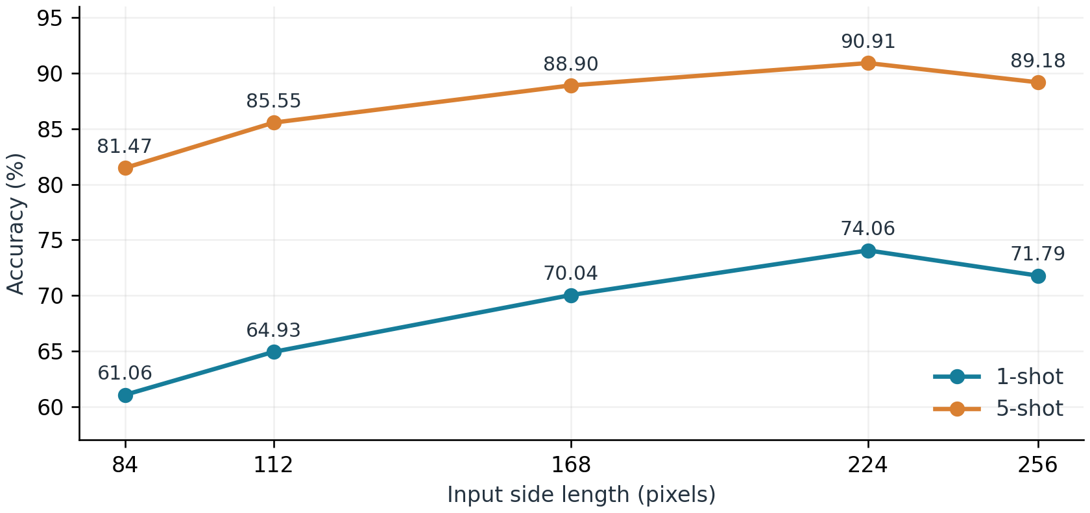
Figure 3. Exploratory MobileNetV3-Small resolution sweep. Each point uses one training seed and 500 test episodes. Error bars are omitted because the statistical meaning of the source ± terms is unspecified; 224×224 is the observed maximum in this run only.
For a descriptive comparison, define gain/compute as [A(r)−A(84)]/[C(r)/C(224)], where A is 1-shot accuracy in percent and C is the reported backbone compute. Recalculation from the displayed values gives 13.95, 14.17, 13.00, and 8.23 pp per relative-compute unit at 112, 168, 224, and 256 pixels. The highest value is at 168, whose accuracy is 4.02 pp below the observed maximum. This ratio uses total compute, not incremental compute above 84, and its ranking depends on the chosen definition. The more direct observation is that 256 has lower accuracy and greater reported compute than 224 in this single run; other trade-offs depend on the application budget.
4.10 Practical Interpretation
Resolution should be selected jointly with backbone architecture and the deployment constraint. In this pipeline, a compact high-resolution backbone can exceed a larger low-resolution backbone in accuracy while requiring fewer parameters and more operations. Parameter storage, per-image compute, episode latency, and working memory therefore need separate consideration. The current evidence supports choosing among the measured configurations, rather than prescribing a universally best resolution.
5. Discussion
The final results show higher mean accuracy at 224×224 than at 84×84 for all three backbones on both datasets. MiniImageNet gains range from 4.61 to 13.88 pp in 1-shot and from 4.18 to 9.06 pp in 5-shot; CUB gains range from 9.44 to 16.39 pp and from 6.27 to 10.65 pp. Complete pooled matched-episode coverage supports positive differences in all 12 comparisons. This agreement across descriptive and matched evaluations strengthens the within-pipeline result, without eliminating uncertainty about pretraining and optimization effects.
Small exhibits the greatest resolution sensitivity in both shot settings and on both datasets, whereas Large achieves the highest absolute accuracy. ResNet-18 has the largest parameter count but the smallest descriptive gain in each setting. The ordering shows that parameter count, architecture, and sensitivity to input size are distinct characteristics. Compound-scaling research provides context (Tan and Le, 2019; Lin et al., 2023), but three architecture choices do not establish a general scaling law. Pretraining-resolution and batch-size effects remain unisolated.
The pretraining scope is central to interpretation. Class-disjoint evaluation after supervised and episodic training does not undo exposure during external pretraining. The MiniImageNet results should therefore be read as an analysis of few-shot adaptation with pretrained representations, subject to verification of checkpoint provenance, rather than as evidence of recognition of categories unseen throughout training. The CUB results provide complementary within-study evidence, but their custom split and unverified pretraining overlap similarly limit external comparisons.
Higher reported compute and longer measured latency indicate greater computational demands; they do not quantify energy use or carbon emissions. Such estimates require power measurements or a documented energy model. Likewise, no transformer backbone or alternative few-shot algorithm was evaluated. The study establishes an empirical pattern within its tested pipeline and leaves the mechanism and broader transferability open.
6. Limitations
The following limitations define the scope of the evidence and its reproducibility.
Optimization confounding. Batch size changes with resolution, and the available record does not clarify its unit or the relationship between the reported episode budget and optimizer updates. The 256-pixel batch setting is also unspecified. The sign and magnitude of any resulting optimization effect remain unknown.
Scope of replication. Main accuracy results use three seeds per configuration, and all backbone–dataset–shot settings have pooled matched-episode summaries. Three training replications still provide limited evidence about run-to-run uncertainty. The separate five-resolution sweep uses one seed and one backbone; its apparent peak is exploratory, and the statistical definition of its ± terms is not documented. No convergence study is available.
Statistical interpretation. All 12 within-backbone comparisons have reported pooled paired t and Wilcoxon results, but raw episode arrays and seed-specific paired outputs are not supplied. The statistics can be checked for summary-level consistency, not independently recomputed. Episode-level confidence intervals are conditional on the trained model pairs and do not represent uncertainty over arbitrary retraining. Direct cross-backbone paired comparisons remain unavailable.
Dataset and model coverage. The study includes all three backbones on MiniImageNet and CUB. Coverage remains limited to two datasets and plain ProtoNet-style classification with convolutional representations. Transfer to other tasks, datasets, few-shot algorithms, and transformer architectures is untested.
Summary precision. The final aggregate accuracies and SDs are retained as logged, using the population-form SD convention. Per-seed accuracies and pooled matched quantities are displayed to two decimals. Rounding can cause 0.01 pp discrepancies when reconstructing means or paired differences; these do not justify replacing final outputs with calculations from already rounded numbers. Access to unrounded outputs is needed for exact numerical reproduction.
Reproducibility materials. Code, configuration files, split manifests, checkpoints, and per-episode outputs are not publicly available in the supplied record. Their release would allow verification of the documented pipeline and the remaining ambiguities. No public release is claimed in this manuscript.
7. Conclusion
The final experiments consistently associate 224×224 inputs with higher accuracy than 84×84 within the reported ImageNet-initialized ProtoNet pipeline. This pattern holds for MobileNetV3-Small, MobileNetV3-Large, and ResNet-18 on both MiniImageNet and CUB, in 1-shot and 5-shot classification, and is supported by all 12 pooled matched-episode analyses. Small at 224×224 exceeds Large at 84×84 by 4.46 and 2.03 pp on MiniImageNet and by 8.11 and 4.92 pp on CUB, while using 68.8% fewer parameters and approximately 1.51× its reported compute.
Resolution is therefore a useful design choice alongside architecture and resource budget. The separate single-seed sweep suggests that increasing input size beyond the observed 224×224 peak need not help. These findings do not establish a universal optimum, a resolution-only causal effect, or superiority under a conventional class-disjoint benchmark protocol. Future work should prioritize documenting and auditing pretraining, image provenance, class splits, and optimization accounting, then test the trade-offs under matched training budgets and complete hardware profiling.
References
Bakhtiarnia, A., Zhang, Q., and Iosifidis, A. (2024). Efficient High-Resolution Deep Learning: A Survey. ACM Computing Surveys, 56(7), Article 181.
Chen, W.-Y., Liu, Y.-C., Kira, Z., Wang, Y.-C. F., and Huang, J.-B. (2019). A Closer Look at Few-Shot Classification. International Conference on Learning Representations.
Chen, Y., Liu, Z., Xu, H., Darrell, T., and Wang, X. (2021). Meta-Baseline: Exploring Simple Meta-Learning for Few-Shot Learning. Proceedings of the IEEE/CVF International Conference on Computer Vision.
Finn, C., Abbeel, P., and Levine, S. (2017). Model-Agnostic Meta-Learning for Fast Adaptation of Deep Networks. Proceedings of the International Conference on Machine Learning.
He, K., Zhang, X., Ren, S., and Sun, J. (2016). Deep Residual Learning for Image Recognition. Proceedings of the IEEE Conference on Computer Vision and Pattern Recognition.
Howard, A., Sandler, M., Chu, G., Chen, L.-C., Chen, B., Tan, M., Wang, W., Zhu, Y., Pang, R., and Vasudevan, V. (2019). Searching for MobileNetV3. Proceedings of the IEEE/CVF International Conference on Computer Vision.
Lin, C., Yang, P., Wang, Q., Qiu, Z., Lv, W., and Wang, Z. (2023). Efficient and Accurate Compound Scaling for Convolutional Neural Networks. Neural Networks, 167, 787–797.
Liu, K., Ye, X., Sun, B., Yang, H., Li, H., Xu, R., and Wang, Z. (2024). Low-Resolution Few-Shot Learning via Multi-Space Knowledge Distillation. Information Sciences, 677, Article 120968.
Ravi, S. and Larochelle, H. (2017). Optimization as a Model for Few-Shot Learning. International Conference on Learning Representations.
Russakovsky, O., Deng, J., Su, H., Krause, J., Satheesh, S., Ma, S., Huang, Z., Karpathy, A., Khosla, A., Bernstein, M., Berg, A. C., and Fei-Fei, L. (2015). ImageNet Large Scale Visual Recognition Challenge. International Journal of Computer Vision, 115(3), 211–252.
Snell, J., Swersky, K., and Zemel, R. (2017). Prototypical Networks for Few-shot Learning. Advances in Neural Information Processing Systems.
Tan, M. and Le, Q. (2019). EfficientNet: Rethinking Model Scaling for Convolutional Neural Networks. Proceedings of the International Conference on Machine Learning.
Tian, Y., Wang, Y., Krishnan, D., Tenenbaum, J. B., and Isola, P. (2020). Rethinking Few-Shot Image Classification: A Good Embedding Is All You Need? Proceedings of the European Conference on Computer Vision.
Touvron, H., Vedaldi, A., Douze, M., and Jégou, H. (2019). Fixing the Train-Test Resolution Discrepancy. Advances in Neural Information Processing Systems.
Vinyals, O., Blundell, C., Lillicrap, T., and Wierstra, D. (2016). Matching Networks for One Shot Learning. Advances in Neural Information Processing Systems.
Wah, C., Branson, S., Welinder, P., Perona, P., and Belongie, S. (2011). The Caltech-UCSD Birds-200-2011 Dataset. Technical Report CNS-TR-2011-001, California Institute of Technology.
Wang, H. and Jie, S. (2023). Focus Your Attention when Few-Shot Classification. Advances in Neural Information Processing Systems.
Ye, H.-J., Hu, H., Zhan, D.-C., and Sha, F. (2020). Few-Shot Learning via Embedding Adaptation with Set-to-Set Functions. Proceedings of the IEEE/CVF Conference on Computer Vision and Pattern Recognition.
Zeng, W. and Xiao, Z. (2024). Few-Shot Learning Based on Deep Learning: A Survey. Mathematical Biosciences and Engineering, 21(1), 679–711.
Zhang, C., Cai, Y., Lin, G., and Shen, C. (2020). DeepEMD: Few-Shot Image Classification with Differentiable Earth Mover's Distance and Structured Classifiers. Proceedings of the IEEE/CVF Conference on Computer Vision and Pattern Recognition.
Appendix A. Per-Run MiniImageNet Results
Configuration | 1-shot S1 | 1-shot S2 | 1-shot S3 | 5-shot S1 | 5-shot S2 | 5-shot S3
MobileNetV3-Small 84×84 | 61.56 | 59.52 | 59.60 | 81.73 | 81.30 | 81.74
MobileNetV3-Small 224×224 | 74.07 | 74.22 | 74.01 | 90.89 | 90.10 | 90.94
MobileNetV3-Large 84×84 | 69.43 | 69.77 | 69.72 | 88.24 | 88.49 | 89.12
MobileNetV3-Large 224×224 | 81.03 | 80.49 | 78.77 | 92.81 | 93.21 | 93.21
ResNet-18 84×84 | 64.83 | 63.80 | 64.24 | 81.25 | 81.85 | 82.57
ResNet-18 224×224 | 69.62 | 69.29 | 67.81 | 85.82 | 85.78 | 86.62
Final MiniImageNet per-seed accuracies (%), reproduced from the three backbone result files. Tables 1 and 2 retain the logged aggregate means and population-form SDs. Because individual runs are rounded to two decimals, their recomputed average can differ from the logged mean by 0.01 pp.
Appendix B. CUB-200-2011 Per-Run Results
Configuration | 1-shot S1 | 1-shot S2 | 1-shot S3 | 5-shot S1 | 5-shot S2 | 5-shot S3
MobileNetV3-Small 84×84 | 65.28 | 66.11 | 63.43 | 82.75 | 82.23 | 80.98
MobileNetV3-Small 224×224 | 81.25 | 81.56 | 81.17 | 92.90 | 92.55 | 92.46
MobileNetV3-Large 84×84 | 73.84 | 73.42 | 72.39 | 87.88 | 87.43 | 87.85
MobileNetV3-Large 224×224 | 84.65 | 85.31 | 84.32 | 94.71 | 94.56 | 94.47
ResNet-18 84×84 | 71.58 | 71.04 | 70.66 | 86.21 | 85.87 | 85.56
ResNet-18 224×224 | 80.55 | 81.43 | 79.62 | 92.30 | 92.14 | 92.02
Final CUB per-seed accuracies (%) for all three backbones. Table 4 retains the logged aggregate means and population-form SDs. The CUB split follows the reported random.Random(42) procedure; its class ordering and complete split manifest are needed for exact replication.
Appendix C. Reproducibility and Statistical Notes
The final three backbone outputs are the source of Tables 1–4, the study rows in Table 7, and Figures 1–2. Aggregate means and SDs are retained as logged. SD denotes the population-form dispersion across the three observed seeds (denominator 3), not an estimated standard error or confidence interval. Table 2 uses differences of displayed aggregate means. The earlier operation estimates, ResNet-18 timings, and single-seed sweep remain separately identified in Tables 5, 6, and 8.
All three backbones have pooled matched-episode results for both datasets and both shot settings. Each comparison contains 6,000 pairs. The final pooled means, Δ, 95% CI half-widths, t statistics, and Wilcoxon statistics are reported directly. Earlier incomplete or inconsistent seed-level summaries are superseded and are not combined with the final results. Values printed as p=0.000000 are expressed as p < 10⁻⁶. The paired Δ may differ by 0.01 pp from subtraction of the displayed marginal means due to rounding. Raw arrays are required to reproduce the test statistics and assess seed-level dependence.
Reproducibility requires the weight identifiers, dataset manifests and native image sizes, exact transforms, batch units and the 256-pixel setting, episode/update accounting, checkpoint selection rule, evaluation mode (including BatchNorm handling), software and hardware details, and the timing procedure. These details are necessary to reproduce the experimental pipeline and resolve the remaining reporting ambiguities.

